Question2:

#include <stdio.h>

int main(){

int num;

printf("Please enter an integer: ");

scanf("%d",&num);

char*output=(num%2==0)? "Even":

(num%3==0)? "Odd":

"Odd and not divisible by 3";

printf("%s\n",output);

return 0;

}

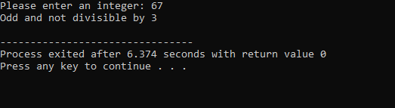

Question4:

#include <stdio.h>

#include <math.h>

int main(){

float radius,area,circumference,squaredradius;

printf("Enter the radius of the tank: ");

scanf("%f",&radius);

area=M_PI*powf(radius, 2);

circumference = 2 * M_PI * radius;

squaredradius=sqrtf(radius);

printf("Area: %.2f\n",area);

printf("Circumference: %.2f\n", circumference);

printf("Square root of radius: %.2f\n", squaredradius);

return 0;

}

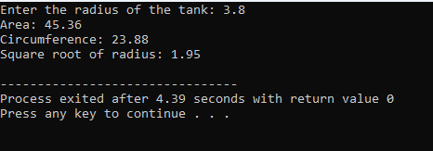

Question5:

#include <stdio.h>

int main(){

int marks1,marks2,marks3,highest;

printf("Please enter the marks of three students: ");

scanf( "%d %d %d", &marks1, &marks2, &marks3);

highest=(marks1>marks2)?((marks1>marks3)? marks1:marks3): ((marks2 > marks3) ? marks2 : marks3);

printf("highest marks is :%d\n",highest);

return 0;

}

